|  |  |  |  |
| --- | --- | --- | --- |
| **Student´ Name:** |  | | |
| **Teacher:** | **ERIKA LOPEZ ALVAREZ.** | **Cycle:** | **2-3** |
| **Subject:** | **ENGLISH** | **Period:** | **1** |
| **Date:** | **28 th January of 2016.** | **Guide:** | **2** |

**MY DAILY ROUTINE.**

**The daily routines are the all actions that you do all day. Usually, these daily routines are related since you get up and go to sleep.**

**Look some examples relate with daily routine.**

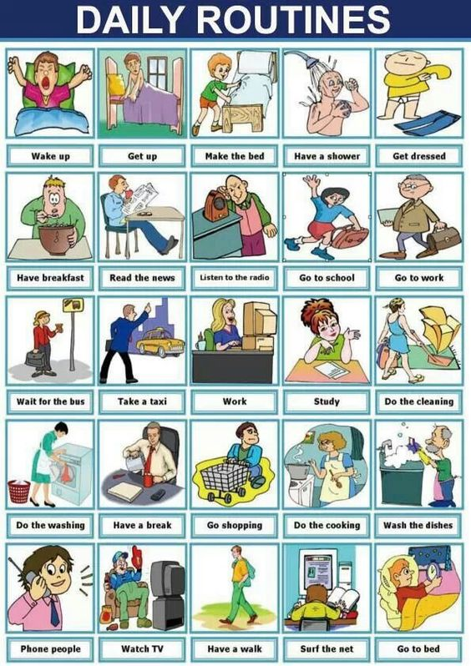

**SIMPLE PRESENT TENSE.**

**AX: DO / DOES.**

**I**

**YOU DO - DON´T**

**HE**

**SHE DOES – DOESN´T**

**IT**

**YOU**

**WE DO- DON´T**

**THEY**

|  |
| --- |
| **FREQUENCY ADVERBS.** |
| **always** (ólweis) - siempre **usually** (iúshuali) - habitualmente **frequently** (fríkuentli) - frecuentemente **often** (ófen) - a menudo **sometimes** (sámtáims) algunas veces **occasionally** (okéishonali) - ocasionalmente **rarely** (rérli) - casi nunca **seldom** (séldom) - casi nunca **hardly ever** (járdli éver) - casi nunca **never** (néver) - nunca |

**STRUCTURES TO CREATE SENTENCES IN SIMPLE PRESENT TENSE.**

**QUESTION:**

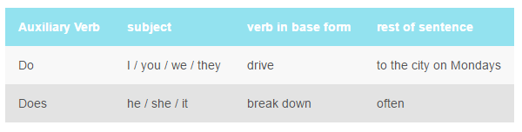

**AFFIRMATIVE SENTENCE:**

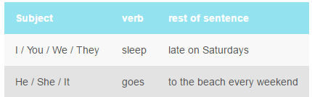

**NEGATIVE SENTENCE:**

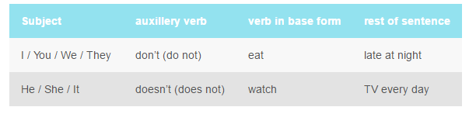

**LET´S PRACTICE.**

1. It´s your turn, write and draw your daily routine.
2. Write 15 sentences about your daily routine, You should identify the parts of each sentence.

Look the example:

**I make the bed SUBJECT: I**

**VERB: Make**

**COMPLEMENT: The bed.**

**HOMEWORK.**

1. Look the next picture and complete the paragraph.

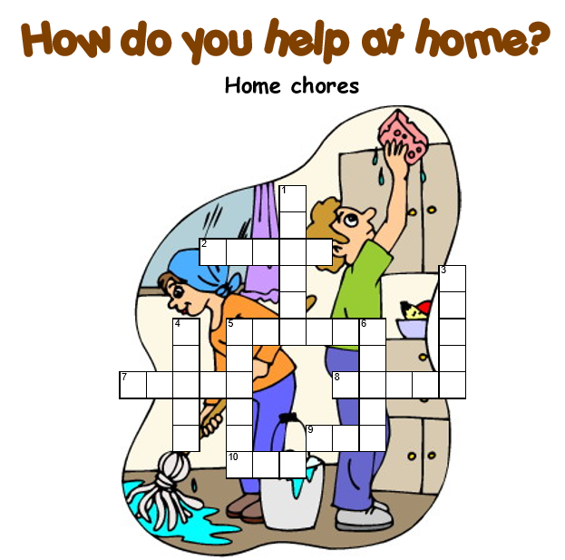

**CLEAN COOKS**

**WATER HELPS**

**MAKES MOP**

**BROOM SET**

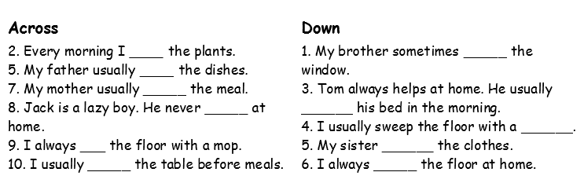**WASHES**

1. Read the next paragraph. You should translate it , please the only tool that you can use is English dictionary .

**On weekdays (from Monday to Friday), I wake up at twenty past seven, but I get up at half past. I have a shower, and then I have breakfast. I usually have a white coffee and toast for breakfast, but some days I have biscuits or cookies! (People in the USA say "cookies" and people in the UK say "biscuits".) After breakfast I get dressed and I go to work at quarter past eight. I walk to the train station. That's about ten minutes. I get the train at 8.30 and I get to Atocha train station at ten to nine, and then I walk to my office.**

**I start work at nine. I work from nine to two, and from three to six in the afternoon. I have lunch in my office. I often have a sandwich and a piece of fruit. Sometimes I have a chocolate bar, too! After work, I go shopping for food and things for the house. I get home before half past seven. I rest a bit, and then I do some housework. At about nine I cook dinner for my family and me. We usually have dinner at half past nine. After that, we watch TV or I read a book. I usually go to sleep in front of the TV set or the book! I'm very tired and finally I go to bed at midnight.**

1. You don´t forget to bring the next materials to create a poster.

* Some pictures related with your daily routine
* A photograph of you
* Some markets, glue, scissors.
* A sheet of Craft paper.

1. Do not forget to study what you have learned in class. The next class, I will be a quiz.